**FUTURISM**

Futurism emerged at the beginning of the twentieth century as a movement that explicitly conceptualised the process of literary and artistic experimentation as part of a far-reaching, systematic strategy of socio-political involvement and cultural transformation. Deliberately theorizing and enacting a radical association between art and life, it defined itself and was considered by its contemporaries as the first, original model of the historical avant-garde.

**ITALIAN FUTURISM**

**Maria Elena Versari, Carnegie Mellon University**

The movement arose from the [*Manifesto and Foundation of Futurism*](http://apicesv3.noto.unimi.it/site/reggi/), a text composed by FILIPPO TOMMASO MARINETTI in 1908 and propagated by its author in Italy, France and worldwide through an intense media campaign at the beginning of 1909. The manifesto was a violent call to embrace modernity in all areas of private and public life and contained famed attacks on the authority of traditional cultural institutions. Marinetti condemned museums and academies, along with the general characteristics and inclinations that he felt dominated life in Italy at the time: femininity, vane aestheticism, a certain moralism and a penchant for rapture. These traditional institutions and cultural attitudes were interpreted as bastions of artistic and ideological inertia, compromise and self-indulgence. Against them, he proposed a series of alternative values derived from the innovations of technology. He theorised surprise, shock and violence as major tools for achieving a cultural *tabula rasa*. Marinetti’s unrivaled talent as a cultural impresario ensured the recruitment of a consistent group of artists and writers. Soon a steady production of additional manifestos followed. Signed by Marinetti and other members of the movement, they outlined their positions on art, literature and politics. Particularly influential were the manifestos that Marinetti conceived for poetry, cinema and theatre. During the 1910s the movement published a wave of manifestos in the fields of music (BALILLA PRATELLA and Russolo), lust and femininity (VALENTINE DE SAINT-POINT), sculpture (UMBERTO BOCCIONI), architecture (ANTONIO SANT’ELIA), and politics (Marinetti, Boccioni, CARLO CARRÀ and LUIGI RUSSOLO). These texts were printed as autonomous leaflets and reproduced in several newspapers and periodicals. Eventually, the movement established its own periodicals, such as *Le Futurisme* and *Artecrazia*. Futurism's expansion into specific artistic or ideological areas coincided with the theoretical activity of its individual members, supervised by Marinetti. UMBERTO BOCCIONI, CARLO CARRÀ, LUIGI RUSSOLO, AROLDO BONZAGNI and ROMOLO ROMANI, for instance, signed the influential [*Manifesto of the Futurist Painters*](http://apicesv3.noto.unimi.it/site/reggi/), at the beginning of 1910. Soon thereafter, GIACOMO BALLA and GINO SEVERINI officially joined the movement, taking the place of Bonzagni and Romani as the official signatories of this manifesto and as members of the movement in the field of the visual arts. The Futurists’ theorization of multi-sensorial experiences applied to the arts, in particular, was crucial in opening the door to modern experiments in the use of noise and assemblage.

In addition to the progressive definition of an artistic and political agenda through manifestos, Futurism used performance strategies and happenings as a way to elicit strong reactions from the audience. In concomitance with World War I, the movement staged a series of astounding public manifestations supporting Italy’s entry into the War. After the conflict, Futurism’s political agenda of nationalism and modernization brought about a short-lived alliance with BENITO MUSSOLINI’s Fasci di Combattimento as well as support for GABRIELE D’ANNUNZIO’s self-appointed government of the city of Fiume. Ideological alliances during this period were quite fluid, attracting to the movement die-hard followers of Mussolini as well as anarchists, socialists and members of the recently founded Italian Communist Party. A significant example of the movement’s involvement with left-wing ideology is the *Manifesto of Futurist Mechanical Art*, signed in 1922 by IVO PANNAGGI and VINICIO PALADINI, and later reworked by ENRICO PRAMPOLINI. In the same period, the movement restructured its artistic identity, which had been hurt by the loss of several of its founding members such as Boccioni (who died in 1916), Carrà and Severini (who left the movement). In the 1920s a new generation of artists, including Prampolini, FORTUNATO DEPERO, FILLIA (Luigi Colombo), FEDELE AZARI and RUGGERO VASARI, developed significant contacts with the international avant-garde, expanding the movement’s presence in the domains of machine aesthetics, architecture, cinema, photography, avant-garde theatre and stage design. After Mussolini’s rise to power in 1922, the Futurists found themselves competing with other organized artistic groups within Italy for the patronage of the regime. The movement continued to be active in the 1930s, expanding its visibility thanks to a series of new manifestos and selected sponsored public works. In the field of painting, the period is characterized by an increasing interest in the plurality of materials, especially evident in Prampolini’s *costruzioni polimateriche*, and by a new reconfiguration of landscape theorized in the *Manifesto of Aeropainting,* signed in 1929 by Marinetti, his wife BENEDETTA CAPPA, Balla, Depero, GERARDO DOTTORI, Fillia, Prampolini, MINO SOMENZI and TATO (Guglielmo Sansoni). In the domain of literature, Marinetti played a central role as both author of Futurist novels, plays and experimental poetry and talent scout for writers and novelists on the rise. Futurism was very influential in the debate on modern architecture, design and advertising in Fascist Italy. Particularly remarkable were the journals and publications edited by Fillia, ALBERTO SARTORIS and Prampolini and the experimental designs for pavilions and exhibiting spaces created by several Futurist architects and designers, such as the aforementioned Fillia, Sartoris and Prampolini, NIKOLAY DIULGHEROFF, VIRGLIO MARCHI and LUCIANO BALDESSARI.

**References and further reading:**

Drudi Gambillo, M., Fiore, T. (1958-63), *Archivi del Futurismo*

Godoli, E. (2001), *Dizionario del Futurismo*

Berghaus, G. (2000), *International Futurism in Arts and Literature* (includes *Bibliography: A Futurist Reference Shelf*)

Cammarota, D. (2006), *Futurismo. Bibliografia di 500 scrittori italiani*

Rainey, L., Poggi, C., Wittman, L. (2009), *Futurism: An Anthology*

Crispolti, E et al. (2010-), *Nuovi Archivi del Futurismo*

**Major Futurist periodicals:**

[*Poesia*](http://circe.lett.unitn.it/ZwebSvr/Zetesis.ASP?WCI=Browse&WCE=MENU)(1905-1909)

[*Lacerba*](http://circe.lett.unitn.it/ZwebSvr/Zetesis.ASP?WCI=Browse&WCE=MENU) (1913-1915)

[*L'Italia Futurista*](http://apicesv3.noto.unimi.it/site/reggi/0002-7291.htm) (1916-1918)

[*La Balza futurista*](http://circe.lett.unitn.it/ZwebSvr/Zetesis.ASP?WCI=Browse&WCE=MENU) (1915)

[*Roma Futurista*](http://apicesv3.noto.unimi.it/site/reggi/0002-7264.htm) (1918-1920)

[*Noi*](http://circe.lett.unitn.it/ZwebSvr/Zetesis.ASP?WCI=Browse&WCE=MENU) (1917-1919; 1920; 1923-1925)

[*Dinamo. Rivista Futurista*](http://apicesv3.noto.unimi.it/site/reggi/0003-0416(1922).htm) (1919)

*Le Futurisme. Revue synthétique bimensuelle* (1922) later [*Le Futurisme. Revue Synthetique Illustrée*](http://apicesv3.noto.unimi.it/site/reggi/0003-0413.htm)(1922-26)

[*Il Futurismo. Rivista Sintetica Bimensile*](http://apicesv3.noto.unimi.it/site/reggi/0003-0416(1922).htm) (1922) later [*Il Futurismo. Rivista Sintetica Illustrata*](http://apicesv3.noto.unimi.it/site/reggi/0003-0408.htm) (1922-1931)

*Der Futurismus* (1922-1923)

[*Futurist Aristocracy*](http://apicesv3.noto.unimi.it/site/reggi/0002-7723.htm) (1923)

[*La città futurista*](http://apicesv3.noto.unimi.it/site/reggi/0002-7366.htm) (1929)

[*La città nuova*](http://apicesv3.noto.unimi.it/site/reggi/0002-7268.htm) (1932-34)

[*Futurismo*](http://circe.lett.unitn.it/ZwebSvr/Zetesis.ASP?WCI=Browse&WCE=MENU) (1932-1933)

[*Dinamo Futurista*](http://circe.lett.unitn.it/ZwebSvr/Zetesis.ASP?WCI=Browse&WCE=MENU) (1933)

[*La terra dei vivi*](http://apicesv3.noto.unimi.it/site/reggi/0002-7371(193310)007.htm) (1933)

[*Sant’Elia*](http://circe.lett.unitn.it/ZwebSvr/Zetesis.ASP?WCI=Browse&WCE=MENU) (1933-1934)

[*Stile Futurista*](http://apicesv3.noto.unimi.it/site/reggi/0002-7705.htm) (1934-1935)

[*Artecrazia*](http://apicesv3.noto.unimi.it/site/reggi/0002-2741.htm) (1934-1939)

**Selected manifestos (see also MARINETTI):**

1909: F. T. Marinetti, *Fondazione e manifesto del futurismo* ([It.](http://apicesv3.noto.unimi.it/site/reggi/0003-0462(1909).htm) and [French](http://apicesv3.noto.unimi.it/site/reggi/0003-0509.htm#http://apicesv3.noto.unimi.it/site/reggi/)).

1909: F.T. Marinetti, *Uccidiamo il chiaro di luna!*

1910: Umberto Boccioni, Carlo Carrà, Luigi Russolo, Giacomo Balla, Gino Severini, *Manifesto dei Pittori futuristi* ([It.](http://apicesv3.noto.unimi.it/site/reggi/0003-0493/(1910)/index.djvu) and [En.](http://apicesv3.noto.unimi.it/site/reggi/0003-0495/(1910)/index.djvu)).

1910: Umberto Boccioni, Carlo Carrà, Luigi Russolo, Giacomo Balla, Gino Severini, *La pittura futurista. Manifesto tecnico* ([It](http://apicesv3.noto.unimi.it/site/reggi/0003-0496/(1910)/index.djvu).).

1911: F.T. Marinetti, *Le Futurisme* (anthology).

1911: Balilla Pratella, *Manifesto dei musicisti futuristi* ([It.](http://apicesv3.noto.unimi.it/site/reggi/0003-0498/()/index.djvu) and [French](http://apicesv3.noto.unimi.it/site/reggi/0003-0500/(1911)/index.djvu)).

1911: Balilla Pratella, *La musica futurista. Manifesto tecnico* ([It](http://apicesv3.noto.unimi.it/site/reggi/0003-0463().htm).).

1912: Valentine de Saint-Point, *Manifesto della donna futurista. Risposta a F.T. Marinetti* ([It](http://apicesv3.noto.unimi.it/site/reggi/0003-0481(1912).htm).).

1912: F.T. Marinetti, *Manifesto tecnico della letteratura futurista* ([It.](http://www.avantgarde-museum.com/en/image/2642/) and [French](http://apicesv3.noto.unimi.it/site/reggi/0003-0509.htm)).

1912: Umberto Boccioni, *Manifesto tecnico della scultura futurista* ([It.](http://apicesv3.noto.unimi.it/site/reggi/0003-0483/(1912)/index.djvu) and [Fr](http://apicesv3.noto.unimi.it/site/reggi/0003-0482/(1912)/index.djvu).).

1912: Valentine de Saint-Point, *Manifesto futurista della lussuria* ([It](http://apicesv3.noto.unimi.it/site/reggi/0003-0484(1913).htm).).

1913: Luigi Russolo, *L’arte dei Rumori. Manifesto futurista* ([It](http://apicesv3.noto.unimi.it/site/reggi/0003-0503(1913).htm). and [French](http://apicesv3.noto.unimi.it/site/reggi/0003-0504(1913).htm)).

1913: Guillaume Apollinaire, *L’antitradizione futurista* ([It](http://apicesv3.noto.unimi.it/site/reggi/0003-0510.htm).).

1913: Carlo Carrà, *La pittura dei suoni, rumori e odori. Manifesto futurista* ([It](http://apicesv3.noto.unimi.it/site/reggi/0003-0491(1913).htm).).

1913: F.T. Marinetti, *Il teatro di varietà. Manifesto futurista* ([It.](http://apicesv3.noto.unimi.it/site/reggi/0003-0507(1913).htm) and [French](http://apicesv3.noto.unimi.it/site/reggi/0003-0508(1913).htm)).

1913: F.T. Marinetti, Umberto Boccioni, Carlo Carrà, Luigi Russolo, *Il programma politico futurista* ([It](http://apicesv3.noto.unimi.it/site/reggi/0003-0454(1913).htm).).

1914: Antonio Sant’Elia, *L’architettura futurista. Manifesto* ([It](http://apicesv3.noto.unimi.it/site/reggi/0003-0514(1914).htm).).

1914: Marinetti (ed.), *I manifesti del Futurismo* (1st series).

1914: Giacomo Balla: *Il Vestito antineutrale. Manifesto futurista* ([It](http://apicesv3.noto.unimi.it/site/reggi/0003-0512.htm).).

1915: F.T. Marinetti, Emilio Settimelli, Bruno Corra, *Il teatro futurista sintetico* ([It.)](http://apicesv3.noto.unimi.it/site/reggi/0003-0505(1915).htm).

1915: Giacomo Balla, Fortunato Depero, *La ricostruzione futurista dell’universo* ([It](http://apicesv3.noto.unimi.it/site/reggi/0003-0513(1915).htm).)

1916: F.T. Marinetti, *La nuova religione morale della velocità* ([It.)](http://apicesv3.noto.unimi.it/site/reggi/0003-0490/(1916)/index.djvu)

1916: F.T. Marinetti, Bruno Corra, Emilio Settimelli, Arnaldo Ginna, Giacomo Balla, Remo Chiti, *Manifesto della cinematografia futurista*.

1917: F.T. Marinetti, *Manifesto della danza futurista* ([French](http://apicesv3.noto.unimi.it/site/reggi/0003-0485.htm)).

1918-1919:Marinetti (ed.), *I manifesti del Futurismo* (4 voll.)

1921: F.T. Marinetti, Francesco Cangiullo, *Il teatro della sorpresa*.

1922: Ivo Pannaggi, Vinicio Paladini, *Manifesto dell’arte meccanica*.

1923: Ivo Pannaggi, Vinicio Paladini, Enrico Prampolini, *L’arte meccanica. Manifesto futurista*.

1924: Fedele Azari, *La flora artificiale ed equivalenti astratti di odori artificiali* ([It](http://apicesv3.noto.unimi.it/site/reggi/0003-0458.htm).).

1929: Giacomo Balla, Benedetta, Fortunato Depero, Gerardo Dottori, Fillia, F.T. Marinetti, Enrico Prampolini, Mino Somemzi, Tato, *Manifesto dell’aeropittura*.

1930: F.T. Marinetti, Fillia, *Manifesto della cucina futurista.*

1931: F.T. Marinetti, Fillia, *Manifesto dell’Arte Sacra Futurista*.

1933: F.T. Marinetti, Pino Masnada, *La Radia. Manifesto futurista.*

1934: Enrico Prampolini, *Al di là della pittura verso i polimaterici*.

1938: F.T. Marinetti, *La poesia dei tecnicismi. Manifesto futurista.*

1940: F.T. Marinetti, Marcello Puma, Pino Masnata, *Calcolo poetico delle battaglie. La matematica futurista immaginativa qualitativa.*

**Artworks and illustrations:**

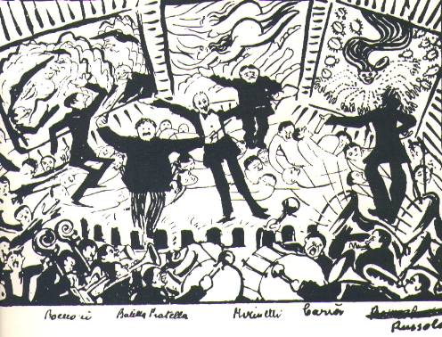

Umberto Boccioni

*A Futurist Soirée*

1911

ink

Link:

http://www.irre.toscana.it/futurismo/opere/immagini/BOCC/Serata.jpg

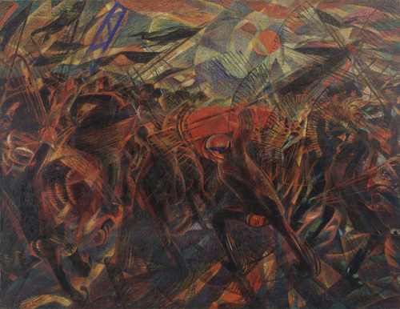

Carlo Carrà

*Funeral of the Anarchist Galli*,

1910-11

Oil on canvas, 198.7 x 259.1 cm

The Museum of Modern Art, New York

link: http://www.moma.org/collection/browse_results.php?criteria=O%3AAD%3AE%3A987&page_number=1&template_id=1&sort_order=1

Giacomo Balla

*Girl running on the balcony*

1912

oil on canvas, 125 x 125 cm

Museo del Novecento, Milan

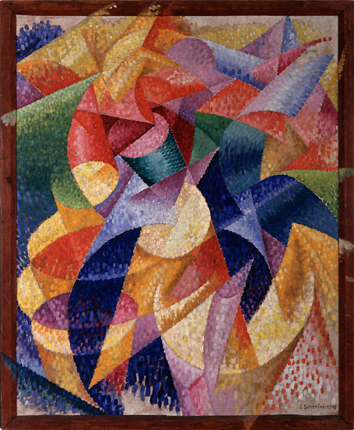

Gino Severini

*Mare=Ballerina (Sea=Dancer)*

1914

oil on canvas, 105,3 x 85,9 cm (including the frame)

Collezione Peggy Guggenheim, Venice

link:

http://www.guggenheim-venice.it/collections/artisti/dettagli/pop_up_opera2.php?id_opera=303

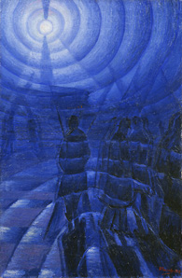

Luigi Russolo

*Solidity of Fog*

1912

oil on canvas, 100 x 65 cm

Gianni Mattioli Collection, on loan to the Peggy Guggenheim Collection, Venice

http://www.guggenheim-venice.it/collections/artisti/dettagli/opere_dett.php?id_art=175&id_opera=404

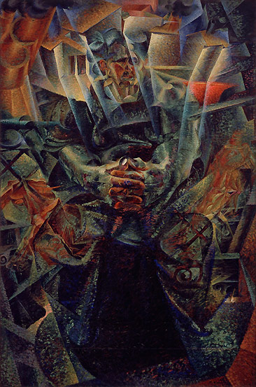

Umberto Boccioni,

*Materia (Matter)*

1912-1913

oil on canvas, 226 x 150 cm

Gianni Mattioli Collection, on loan to the Peggy Guggenheim Collection, Venice

http://www.guggenheim-venice.it/collections/artisti/dettagli/pop_up_opera2.php?id_opera=60

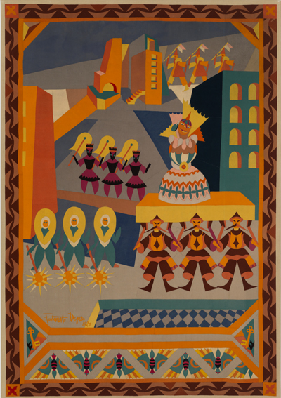

Fortunato Depero,

*Cortège of the Great Doll*

1920

cloth marquetry, 330 x 230 cm

Mart, Trento

http://www.mart.trento.it/collections.jsp?ID_LINK=688&area=137&id_context=3354

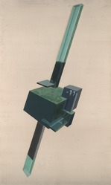

Ivo Pannaggi

*Architectonic Function 3U*

1925-26

oil on canvas, 150 x 90 cm

Yale University Art Gallery, New Haven, CT

http://ecatalogue.art.yale.edu/detail.htm?objectId=44044

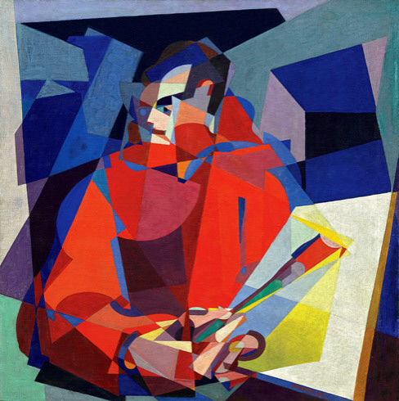

Enrico Prampolini

*Simultaneous Self-Portrait*

1923 circa

oil on canvas, 100.6 x 110.6 cm

Solomon R. Guggenheim Museum, New York

http://www.guggenheim.org/new-york/collections/collection-online/artwork/3499

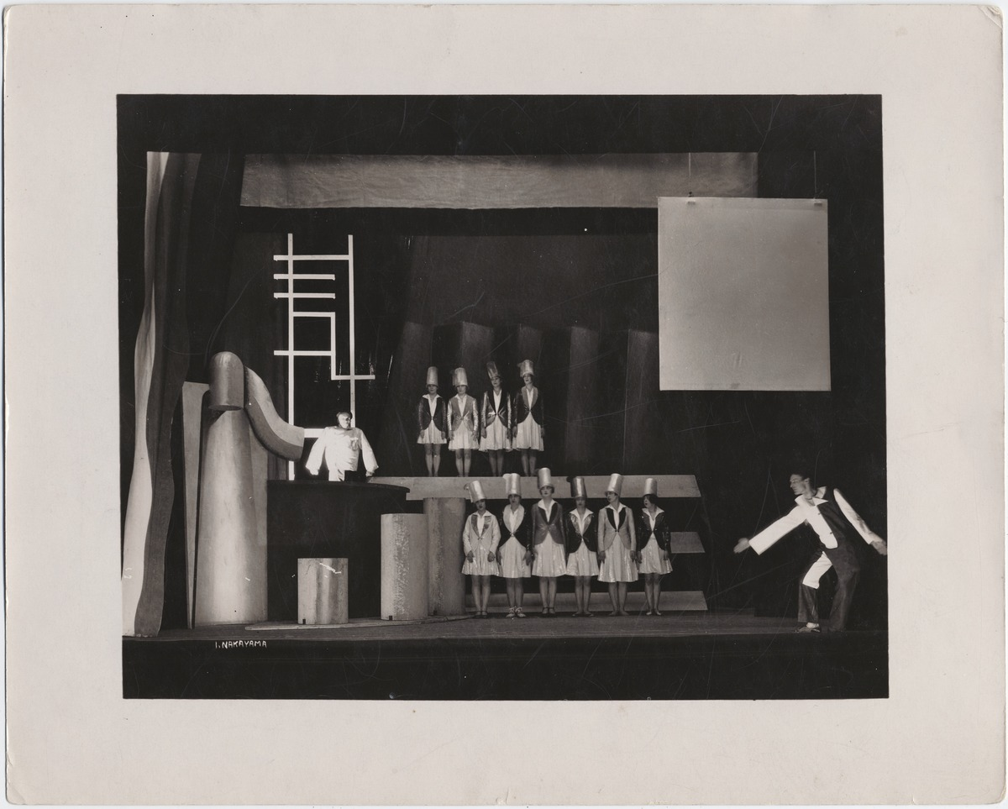

Enrico Prampolini

*Stage set for Marinetti’s Play “Cocktail”*

1927

Teatro della Pantomima Futurista, Paris

<http://brbl-dl.library.yale.edu/vufind/Record/3482756>

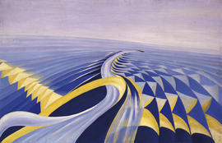

Benedetta Cappa

*Velocity of a speedboat*

1922-24

oil on canvas, 70 x 110 cm

Galleria Comunale d’Arte Moderna, Rome

http://en.galleriaartemodernaroma.it/collezioni/percorsi_per_temi/marinetti_e_i_futuristi/velocita_di_motoscafo

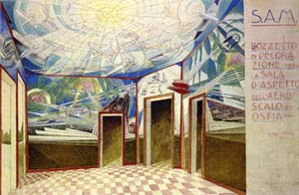

Gerardo Dottori

*Project for the Waiting Room of the Seaplane Airport in the town of Ostia*

1928

watercolor and ink on paper

(reproduced as a postcard)

http://www.futur-ism.it/collezioni/opere/opere.asp?sez=2&det=116

Fillia,

*Sense of Gravity*

1932 circa

oil on canvas

Galleria d’Arte Moderna, Genua

http://www.fondazioneragghianti.it/content.php?p=4.1.50

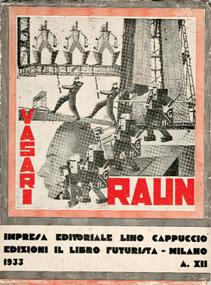

Ruggero Vasari

*Raun (Man and Machine)*

bookcover by Ivo Pannaggi

1933

http://1.bp.blogspot.com/-FdF5KrBY41c/UFYSFYKaaFI/AAAAAAAAAsQ/Hijy_9p33OA/s1600/vasari-raun2.jpg

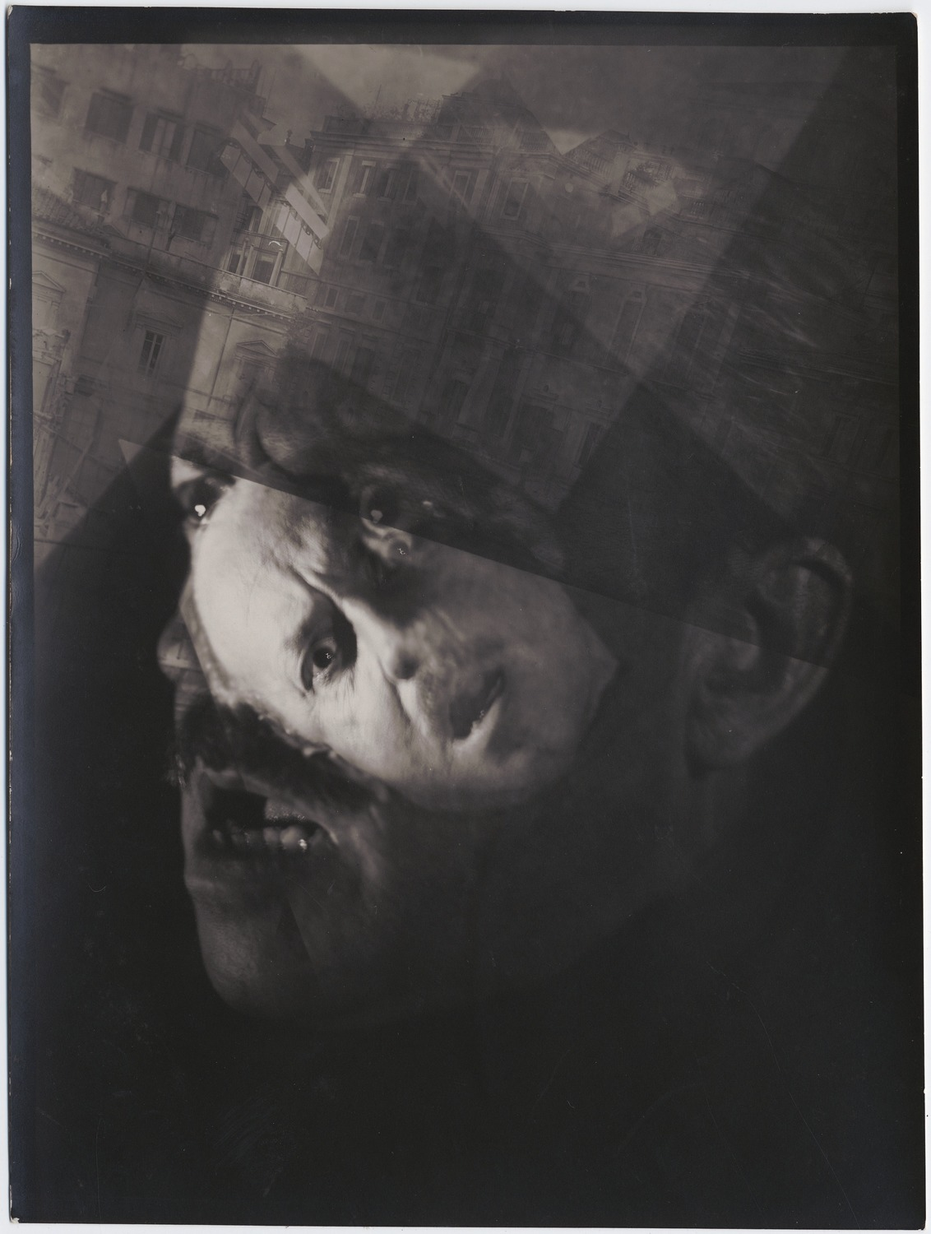

Tato (Guglielmo Sansoni)

*Dynamic Portrait of Marinetti*

1932

photograph, 18 x 24 cm

Beinecke Rare Books and Manuscript Library, Yale University, New Haven CT

http://brbl-dl.library.yale.edu/vufind/Record/3482979

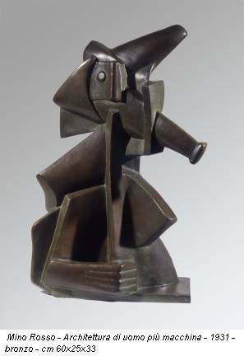

Mino Rosso

*Architecture of Man + Machine*

1931

Bronze, 60 x 25 x33

Private collection

http://www.exibart.com/Print/notizia.asp?IDNotizia=29628&IDCategoria=1

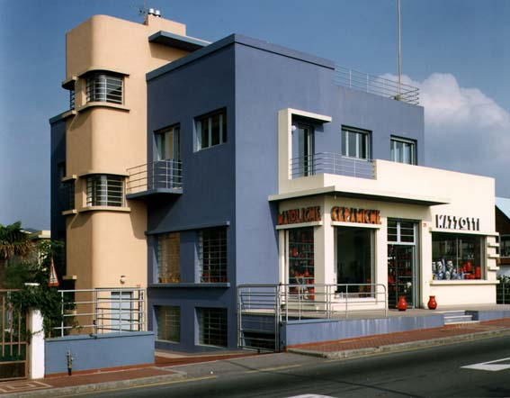

Dicolaj Diulgheroff

Mazzotti House and Shop in Albissola Marina (SV)

1930-34

http://www.tulliodalbisola.it/casa_mazzotti/box03-L20.JPG

**Websites:**

Marinetti reciting his poem *La Battaglia di Adrianopoli*

http://www.ubu.com/sound/marinetti.html

A selection of Futurist Sounds and Music

http://www.irre.toscana.it/futurismo/opere/suoni.htm

Futurism at the Museo del Novecento, Milan

http://museodelnovecento.wordpress.com/2011/03/08/04-futurismo/

Casa d’Arte Depero at the Mart, Trento

http://www.mart.trento.it/casadepero

Archivio del ‘900, Mart

http://www.mart.trento.it/archivio

Primo Conti Foundation

http://www.fondazioneprimoconti.org/

The Wolfsonian-FIU Museum and Research Library, Miami / Wolfoniana, Genoa

http://www.wolfsonian.org/ and http://www.wolfsoniana.it/

Errauchen-Salaris Foundation

http://www.fondazioneechaurrensalaris.it/

Marinetti’s Libroni

http://beinecke.library.yale.edu/collections/highlights/filippo-tommaso-marinettis-libroni-futurism

The Getty Research Institute, Special Collections

http://www.getty.edu/research/special_collections/

Beinecke Rare Books and Manuscript Library

http://beinecke.library.yale.edu/collections

The International Yearbook of Futurism Studies

http://www.degruyter.com/view/j/futur

Scholarly and general news updates on Futurism

http://www.italianfuturism.org/

**RUSSIAN FUTURISM**

**Connor Doak, University of Bristol**

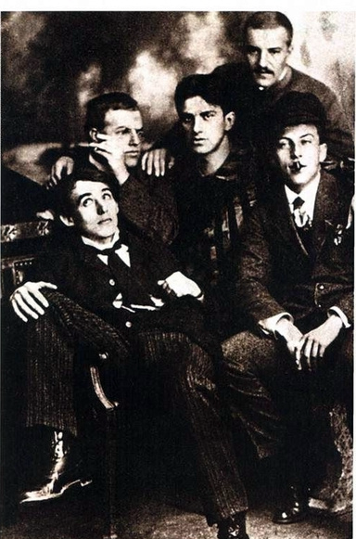An avant-garde movement dedicated to radical poetic experimentation to meet the needs of the dynamic modern era. From obscure beginnings in 1910, Russian Futurism reached its zenith during the years 1912–14, before losing cohesion during the First World War. After 1917, many Futurists produced literature in service of the Bolshevik revolution, but they became marginalized in the late 1920s as experimental writing fell out of favour. Several competing groups adopted the name “Futurists,” including, in Russia, the Ego-Futurists, Hylaea (also known as the Cubo-Futurists), and the Mezzanine of Poetry. Of these groups, Hylaea produced the most enduring literature. Hylaea included the Burliuk brothers (David, Nikolai, and Vladimir), Elena Guro, Velimir KHLEBNIKOV, Vasilii Kamenskii, Aleksei Kruchenykh, Benedikt Livshits, and Vladimir MAYAKOVSKY. Khlebnikov and Kruchenykh proved the most experimental writers, developing a transrational language (*zaum’*) made up of newly-coined words which had no denotative meaning, with their power depending on their sonic and graphic import alone. Mayakovsky demonstrated his originality through inventive imagery, a colloquial immediacy, and his creative use of rhyme, rhythm and poetic structures. While poetry and the manifesto proved the literary forms most conducive to Futurist experimentation, Futurists also wrote drama and prose fiction.

A group of Hylaea Futurists in 1912. Standing: N. Burliuk; Seated L-R: Kruchenykh, D.Burliuk, Mayakovsky, Livshits.

David Burliuk, who served as an organizer of the Hylaea group, dates the origins of Futurism to the publication of the collection *Sadok sudei* (A Trap for Judges) in 1910. However, as early as 1907-08, Khlebnikov's poetry shows the hallmarks of verbal experimentation that would later be labelled Futurist. Despite the Futurists' frequent denunciations of Russian SYMBOLIST poetry, the Symbolists undeniably influenced them, especially in their innovative use of poetic forms, their synaesthesia, and their distaste for Realist aesthetics. However, unlike the Symbolists, who often sought a Neo-Platonic transcendence through poetry, the Futurists rather focused on the intrinsic value of the word. The best Futurist poetry is characterized by verbal innovation, sound-patterning, and linguistic play, as in the following much-anthologized poem by Khlebnikov, written in 1908–09 but not published until 1912:

Бобэóби пелись губы, Bobay*oh*bee sang the lips,

Вээóми пелись взоры, Vayay*oh*mee sang the glances,

Пиээо пелись брови, Peeayayoh sang the eyebrows,

Лиэээй — пелся облик, Leeayayay — sang the visage,

Гзи-гзи-гзэо пелась цепь. Gzee-gzee-gzayoh sang the chain.

Так на холсте каких-то соответствий And so on a canvas of certain correspondences

Вне протяжения жило Лицо. Outside dimension there lived a Face.

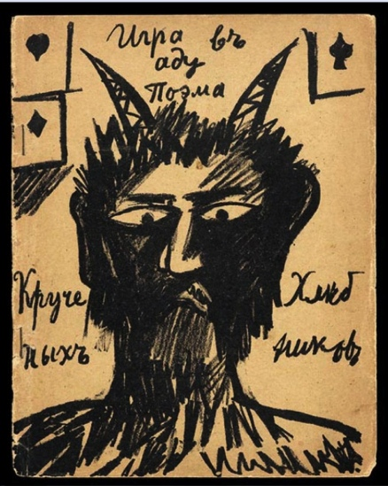Like their Italian counterparts, Russian Futurist writers collaborated closely with visual artists. Indeed, many writers—including Guro, Mayakovsky and Kruchenykh—began their careers as painters and translated painterly techniques to the written word. The Futurists often designed their own books. Unlike the lavish, gilded volumes of their Symbolist predecessors, early Futurist books were diminutive and ephemeral, often printed on wallpaper, and illustrated with Neo-primitivist drawings by artists such as Natal’ia GONCHAROVA, Mikhail LARIONOV, Kazimir MALEVICH and Olga Rozanova.

While the Italian Futurists, led by Marinetti, celebrated technology, speed, and the modern metropolis, Russian Futurists had a more ambivalent attitude towards modernity and emphasized formal innovation as the key marker of the new poetry. Moreover, several HylaeaFuturists evinced an interest in primitivism not found among the Italians. Khlebnikov and Kruchenykh in particular drew inspiration from Russia's pre-Petrine past and their linguistic experiments often evoke an ancient Slavic language free of Western influences. Indeed, Khlebnikov's preferred term for "Futurist" was not the Latinate *futurist* imported into Russian, but his own coinage from a Slavic root, *budetlianin*.

Cover of Khlebnikov and Kruchenykh's *Igra v adu: Poema* (*A Game in Hell: A Poem*), illustrated by Natalia Goncharova, 1912. Such Neo-primitivist drawings often accompanied Futurist writings.

Yet while the Hylaea Futurists firmly protested their independence from Marinetti, he influenced at least the tone of their work, particularly their provocative manifestos. The most famous of these manifestoes was "Poshchechina obshchestvennomu vkusu” (“A Slap in the Face of Public Taste”), which gained the group instant notoriety upon its appearance in December 1912. Signed by David Burliuk, Mayakovsky, Khlebnikov and Kruchenykh, the manifesto urged Russians to "[t]hrow Puskhin, Dostoevsky, Tolstoy, etc. overboard from the Ship of Modernity" and called upon poets to pursue "Slovo-novshestvo” (“Word-novelty”).

The following year, 1913, has been called the *annus mirabilis* of Russian Futurism. The Hylaea group published a number of miscellanies including *Sadok sudei II* (A Trap for Judges II), *Trebnik troikh* (Prayerbook of Three) and *Dokhlaia luna* (The Croaked Moon) among others. Kruchenykh and Khlebnikov’s influential booklet *Slovo kak takovoe* (The Word as Such) also appeared in 1913, which defended their use of “chopped-up words, half-words, and [...] *zaum’*” to create a “swift language of modernity.” The Futurists’ approach to the word played an instrumental role in inspiring the Russian Formalists, particularly the work of Viktor Shklovsky and Roman Jakobson, both of whom were close to the Hylaea circle in the 1910s.

The Futurists courted controversy in their public readings, often appearing in face paint and outrageous attire, and making provocative jibes about the audience. Mayakovsky’s stage presence in particular brought him both acclaim and infamy: he became renowned for his trademark yellow blouse and his booming voice, which admirer Elsa Triolet described as having "the strength and volume of a cathedral organ.” Mayakovsky played the role of himself in his experimental play *Vladimir Maiakovskii: Tragediia* (Vladimir Mayakovsky: A Tragedy), which opened alongside Kruchenykh’s Futurist opera *Pobeda nad solntsem* (Victory Over the Sun)in December 1913 to bemused St. Petersburg audiences.

In 1914, the turmoil unleashed by the outbreak of the First World War seemed to vindicate the poetics of dislocation and fragmentation found in the Futurists' writing. Yet as the Futurists increasingly gained prestige among the literary establishment, their iconoclastic appeal declined. Moreover, the movement started to lose cohesion as the writers began to publish separately rather than collectively. However, individual Futurists produced a number of important works during this period: Mayakovsky completed long poems such as “Oblako v shtanakh”(“Cloud in Trousers”), “Fleita-pozvonochnik” (“The Backbone Flute”), and “Voina i mir” (“War and the Universe”). Khlebnikov’s experimental prose piece *Ka* was first published in 1916.

Futurist ranks grew thin during the latter years of the war and the subsequent Civil War. Vladimir Burliuk was killed in combat in 1917; in 1920, David Burliuk emigrated and Nikolai Burliuk was executed. Khlebnikov died in 1922. However, Futurism flowered in this period in the city of Tiflis (now Tbilisi) where Kruchenykh collaborated with Igor’ Terent’ev and Il’ia Zdanevich to form a new Futurist group, 41°. As T. Nikolskaia notes, their work bore resemblances to DADA in its inclination towards alogism and irrationality. Zdanevich became involved in the Paris Dada movement after moving to France in 1921.

Following the October Revolution of 1917, a number of Futurists remaining in Russia produced art in support of the Bolshevik cause: in 1919 Mayakovsky was involved in the short-lived Communist-Futurist group *Komfut* which combined radical Futurist artistic principles with revolutionary politics. Mayakovsky also played an instrumental role in *LEF* (Left Front of Arts) in the 1920s, where he was joined by Kruchenykh, but this group endorsing artistic experimentation faced increasing marginalization in the Soviet Union and disbanded in 1929. Mayakovsky committed suicide in 1930; Livshits was executed in 1938 for alleged anti-Soviet activity. Kruchenykh died in obscurity in 1968.

A number of other literary groups identified as "Futurists" in Russia. Igor’ Severianin was the leading figure of Ego-Futurism, a movement formed in St. Petersburg in 1911. As the name suggests, Ego-Futurists wrote poetry hyperbolically glorifying the self; their work also reflects an urbanism borrowed from Italian Futurism. Temporarily allied with the Ego-Futurists was the Moscow-based Mezzanine of Poetry, organized by Vadim Shershenevich and the artist Léon Zack. Shershenevich translated Marinetti and his poetry too shows an urbanist bent similar to that of the Italian Futurists. Finally, Sergei Bobrov organized the Centrifuge in January 1914. Although this group rejected the name “Futurists” and tended to avoid the more provocative antics associated with the movement, their analytical attitude towards the poetic word and metrical experimentation have led most critics to consider them an offshoot of Russian Futurism.

**UKRAINIAN FUTURISM**

In Ukraine, Futurism's leading figure was Mykhail’ Semenko, whose two collections *Derzannia* (Bravado) and *Kvero-futurzym* (Quaero-Futurism), caused a scandal upon their appearance in 1914. His theatrical self-promotion, verbal experimentation and the aggressive, colloquial tone of his manifestoes show the influence of Russian and Italian Futurism, although his use of the Ukrainian language, his attacks on the "national" principle in art, and his critical engagement with the Ukrainian canon make him a unique and compelling figure. Ukrainian Futurism came of age in the 1920s, following the interruptions of the First World War and Civil War. Semenko founded Aspanfut (The Association of Pan-Futurists) in 1921, which published controversial collections such as *Semafor u maibutnie* (Semaphore into the Future) and *Katafalk iskusstva* (Catafalque of Art) in 1922. Others involved in Aspanfut included Geo Shkurupii, Mykola Bazhan, and Oleksa Slisarenko and two leading figures in Ukrainian theatre, Marko Tereshchenko and Les' Kurbas, also lent their support.

One of Semenko’s major innovations lay in his technique of *poezomaliarstvo* (poetry-painting), a form of image poetry that created visual interest through the shape of the poem while also utilizing sound-patterning of vowels. The following short poem, “Sil’s’kii Peizazh” (“Rural Landscape”), written in 1922, uses this technique effectively to represent the sounds of the countryside:

О O

А О A O

А О О A O O

А О О О A O O O

П А В Л О P A V L O

П О П А С И T E N D T O

К О Р О О В У T H E C O O W

The reader, encountering these lines that grow in length, may imagine overhearing one peasant calling another with increasing volume and a mounting sense of urgency.

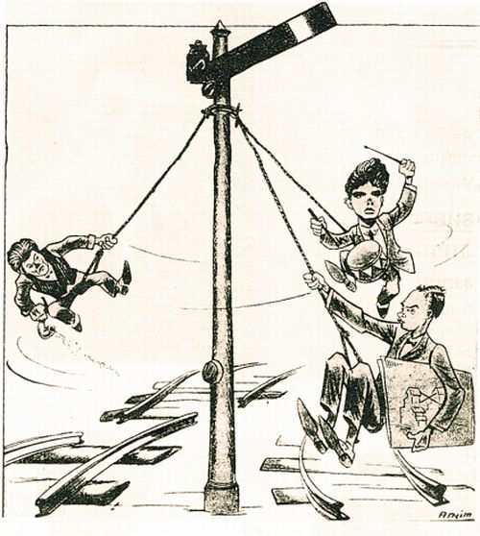 As the political climate of Soviet Ukraine changed in the 1920s, Aspanfut suffered the same political difficulties as LEFin Russia, and struggled against accusations that it was too experimental and too detached from the proletariat. The group reformed twice in the 1920s, first as the Association of Communist Culture (AsKK) in 1924 and as New Generation in 1927. However, in 1930 the group disbanded completely under political pressure, and the defeated Semenko wrote a 1931 poem apologizing for his past errors. In 1937, Semenko, Shkurupii, and Slisarenko were executed. Bazhan turned away from Futurism and became a major public figure in Soviet Ukrainian literature. He died in 1983.

"Semenko, Shkurupii and Bazhan send semaphore signals to the Future". Caricature of the Ukrainian Futurists in the journal *Globus*, April 1927.

**REFERENCES AND FURTHER READING**

**Anthologies**

Folejewski, Z. (ed.) (1980) *Futurism and its Place in the Development of Modern Poetry: A Comparative Study and Anthology*. Ottawa: The University of Ottawa Press. An ambitious volume that includes both a comparative critical history of Futurism in its Italian, Russian, Ukrainian, Polish, Czech, Portuguese and Brazilian variants and an anthology with a few selected Futurist works from each tradition. While the volume is too slender to do justice to these varied traditions, it is useful for its unusually broad scope and its bilingual facing translations.

Lawton, A. & Eagle, H. (eds.) (2004) *Words in Revolution: Russian Futurist Manifestoes 1912-1928.* Washington, DC: New Academia Publishing. Anthology of Russian Futurist manifestoes translated into English. Also includes an introductory essay on Russian Futurism, covering the importance of the manifesto in the different movements.

Proffer, E. & Proffer, C.R. (eds.) *The Ardis Anthology of Russian Futurism*. Ann Arbor, MI: Ardis, 1980. Anthology with English translations of poetry and prose by Khlebnikov, Nikolai Burliuk, Maiakovskii, Khlebnikov, Osip Brik, Guro, and Pasternak. Also includes critical writings by the Futurists and several scholarly articles on the Futurists. Concludes with a series of images, including Futurist books, photographs of the authors, and artworks.

**Memoirs**

Jakobson, R. & Jangfeldt, B. (ed.), trans. Rudy, S. (2004) *My Futurist Years*. New York: Marsilio Publishers. This memoir covers Jakobson’s connections with the Hylaea Futurists, and the volume also includes selected letters, poems and prose, as well as his major critical essays on the Futurists translated into English.

Kruchenykh, A. & Duganov, R. (ed.). trans. Myers. A. (1995) *Our Arrival: From the History of Russian Futurism*. Moscow: RA, 1995. Kruchenykh’s rather scattered observations on Futurism focus mostly on the early years. Written in the 1930s, these memoirs show the imprint of Soviet ideology, and thus, Kruchenykh over-emphasizes the political nature of early Futurism. Includes an introductory essay by Duganov.

Livshits, B., trans. Bowlt, J. (2004). *The One-and-a-Half-Eyed Archer.* St. Petersburg, Russia: Palace Editions. Livshits’ memoir provides a lucid, readable and opinionated account of the lives of the Hylaea Futurists and their literary production. This edition includes extensive annotations and lavish illustrations.

Triolet, E., trans. De Muth, S. (2002) *Mayakovsky: A Memoir*. London: Hearing Eye.

**Selected Critical Works**

Gurianova, N. (2012) *The Aesthetics of Anarchy: Art and Ideology in the Early Russian Avant- Garde*. Berkeley: University of California Press. Critical study of the ideology of Russian avant-garde art and literature. Gurianova emphasizes the anarchistic and anti-teleological nature of pre-revolutionary Futurism, and argues that the Soviet groups such as LEF that emerged in the 1920s represented a departure from this aesthetic and ideology.

Janecek, G. (1996) *Zaum: the Transrational Poetry of Russian Futurism*. San Diego: San Diego State University Press. This monograph provides a thorough and accessible treatment of *zaum’*, covering not only the work of Khlebnikov and Kruchenykh, but also Shklovsky’s critical work on *zaum’*, lesser-known poets, the 41° group in Tiflis, and critical debates about *zaum’* in the1920s. Includes a valuable bibliography.

Markov, V. (1968) *Russian Futurism: A History*. Berkeley, CA: University of California Press. Markov's magisterial volume remains the standard history and critical text on Russian Futurism, offering comprehensive coverage of all the major groups involved. Includes an excellent bibliography of Futurist publications organized by group, but the bibliography of criticism is now dated.

Nikolskaia, T.L., trans. Janecek, G. (1998) “The Reception of Dadaism in Georgia,” in Janecek,G. & Omuka, T. (eds.), *The Eastern Dada Orbit: Russia, Georgia, Ukraine, Central Europe, and Japan*. New York: G.K. Hall & Co., 1998.

Perloff, M. (2003) *The Futurist Moment: Avant-Garde, Avant-Guerre, and the Language of Rupture*. 2nd ed. Chicago: University of Chicago Press. Perloff’s study examines the Futurist worldview and how that worldview is expressed in their experimental artistic and literary techniques. Includes an impressive comparative examination of Russian and Italian Futurism as well as a chapter on Ezra Pound, the Vorticists and *Blast*.

**Online Resources**

**Futurist Books**

1. Getty exhibition "Tango with Cows: Book Art of the Russian Avant-Garde, 1910-1917". Includes several digitized Futurist books available for download in their entirety.

http://www.getty.edu/art/exhibitions/tango_with_cows/

**Futurist Poetry Recordings**

1. Explodity: An Evening of Transrational Sound Poetry at University of Pennsylvania. Includes thirty-one separate MP3 files of Kruchenykh and Khlebnikov's poetry, read by Oleg Minin (in Russian) and Christian Bök, Alison Pulltz and Steve McCafferty (in English translation).

http://writing.upenn.edu/pennsound/x/Explodity.php

2. UbuWeb Futurist Poetry Collection. Twenty-two audio recordings, including David Burliuk, Kamenskii, Kruchenykh and Maiakovskii reading their own poetry, and Roman Jakobson and others reading Khlebnikov. Website and titles in English, readings in Russian only:

http://ubu.com/sound/russian_futurists.html

3. Recordings of Maiakovskii reading his poems. Readings in Russian, but the website presents the texts of the poems in Russian with facing English translation:

http://max.mmlc.northwestern.edu/~mdenner/Demo/poetpage/mayakovsky.html

4. Recordings of Khlebnikov's poetry read by Jakobson and others (in Russian):

http://hlebnikov.com/57/chtenie-stikhov-velimira-khlebnikova

5. Recordings of Semenko's poetry read by others (website and readings in Ukrainian):

http://muzofon.com/search/Михайль-Семенко

**Futurist Theatre**

1. Set design and poster for Maiakovskii's 1913 play *Vladimir Maiakovskii: A Tragedy*:

http://max.mmlc.northwestern.edu/~mdenner/Drama/plays/atragedy/1tragedy.html

2.Malevich's set design and costumes for the 1913 Futurist opera *Victory over the Sun*. The music was by Mikhail Matiushin, libretto by Kruchenykh, and prologue by Khlebnikov.

<http://max.mmlc.northwestern.edu/~mdenner/Drama/plays/plays.htm>

**Images to be** **embedded into the article text**

1. Source Appears in many publications, including Kruchenykh, A. & Duganov, R. (ed.). trans. Myers. A. (1995) *Our Arrival: From the History of Russian Futurism*. Moscow: RA, 1995, 126.

2. Source: <http://www.getty.edu/art/exhibitions/tango_with_cows/gameinhell.html>

3. Source: http://www.segodnya.ua/news/14239944.html

**Sound Clips to be embedded in the article text**

**Audio Clip 1 [futurism-1.mp3]**

2009 recording of Khlebnikov's "Bobeobi pelis' guby" read by Oleg Minin, followed by Paul Schmidt's translation “Bo-beh-oh-bee is the lipsong,” read by Christian Bök. [downloaded from http://media.sas.upenn.edu/Pennsound/groups/Getty/Tango-with-Cows/Getty-Research_Minin-Oleg_12_Bo-beh-oh-bee_Explodity_2-4-09.mp3]

**Audio Clip 2 [futurism-2.mp3]**

Recording of Maiakovskii reading his "A Vy mogli by?" [And Could You?]

[downloaded from [http://max.mmlc.northwestern.edu/~mdenner/Demo/audiofiles/New%20Audio/andcouldyou.mp3]x`](http://max.mmlc.northwestern.edu/~mdenner/Demo/audiofiles/New%20Audio/andcouldyou.mp3%5dx%60)

**FUTURIST ARCHITECTURE**

**Adam Evans, University of Central Lancashire**

The members of the futurist group most associated with architecture during the movement were Antonio Sant'Elia (1888- 1916), Virgilio Marchi (1895- 1960), Enrico Prampolini (1894- 1956), Ivo Pannaggi (1901- 1981) and Angiolo Mazzoni (1894- 1979). Antonio Sant’Elia was born in Como, Italy and graduated from a local institution in 1906 with the qualification of master builder. His first career was as a draughtsman within the city architects department of Milan, and he subsequently studied architecture at Accademia di Brera between 1909 and 1911. In 1912 he designed and built the Villa Elisi in San Maurizio, Como, which shows little relationship to the futurist architecture he would advocate, although there are subtle suggestions apparent in one first floor window detail.

Following the[*Manifesto and Foundation of Futurism*](http://apicesv3.noto.unimi.it/site/reggi/)*,* the architectural facet of the futurist movement became explicit in July 1914 after the publication of Antonio Sant’Elia’s manifesto *Futurist Architecture*, a text document supported by sixteen architectural drawings exploring proposals for a futurist city (three of which were prepared by Mario Chiattone), contesting the very presence of architecture in its current context stating: “Architecture has not existed since the year 700.” The manifesto continued its radical commentary by dismissing Neo-classicism and all forms of decorative architecture as “absurd” and advocated “raw, naked, or violently coloured materials” that would empower futurist architecture to arrive at its own definition of decoration. Complementing this abrasive dismissal of ornament and decoration, futurist architecture should seek inspiration within the industrial and mechanical man-made world; declaring that futurist architecture will be one of “cold calculation, bold audacity and simplicity.”

Sant’Elia’s designs of the supporting proposals followed the text clearly - visually elements were dynamically executed with the use of ellipses and powerful lines, forms were stretched and extruded, emphasising the celebration of speed and movement that was to become a recognisable language of futurist architecture. The proposals also rejected ornament and decoration with a particular bias for an aesthetic of modern living and values of sensibility, themes common in many strands of modernism. This work was first presented as untitled work as part of an exhibition on modernism in May 1914, immediately after which Sant’Elia joined MARINETTI who reviewed the text and published it as a manifesto.

In 1916, both Sant’Elia and Umberto Boccioni (who was a futurist and sculptor with an architectural interest) were fatally wounded during World War I, and subsequently Marinetti looked to Virgilio Marchi to champion futurist architecture. Virgilio Marchi was a production designer and an architect, and taking a lead from both Sant’Elia’s architecture and Giacomo Balla’s paintings, he wrote a second manifesto of architecture in 1920 entitled *Manifesto of Dynamic Instinctive Dramatic Futurist Architecture,* and followed with his book *Architettura Futurista* in 1924 which sought to further establish his critical position within the futurist group. The two texts were intended to campaign for futurist architecture but were much more aligned to stage set design and interiors, before Marchi himself shifted to other interests during the 1930s.

Ivo Pannaggi was born in Macerata, and whilst he studied architecture in Rome and Florence, he ultimately became a practitioner of art. Marinetti revived the futurist movement after the Great War, and with Vinicio Paladini, Pannaggi wrote the *Manifesto of Futurist Mechanical Art* in 1922. Although not explicitly mentioning architecture, this manifesto strongly referenced earlier futurist manifestos and the appreciation of industrial steel and its associated mechanics that were shaping the world. These contextual observations were explicitly painted by Pannaggi in some works celebrating the human actions of making and construction, two examples being *Il Lavoro,* and *I costruttori,* both 1925, exploring themes also celebrated in Russian Constructivism of the same period. A natural progression for Pannaggi was to develop designs for futurist clothing that continued the theme of the body and industrial materials.

In 1930 and fourteen years after Sant’Elia’s fatal wounding in World War I, the city authorities of Como commissioned a memorial to the fallen of the Great War. The design was based on one of Sant’Elia’s visionary structures following Marinetti’s influence on the client. Enrico Prampolini, although a stage designer, had designed the 1927 *Futurist Pavilion* in Turin, and was appointed as project leader. However, the project fell behind schedule and during 1931 the city had appointed fascist architect Giuseppe Terragni (and his brother Attilio) to complete the design and procurement of the memorial. The result was a completed building which does embody some qualities of futurist architecture; although Terragni’s rationalist approach is evident in the form of the elements and their proportions, together with the introduction of Serizzo granite and Nabresina marble as finishing materials.

Exemplars of formative futurist architecture never directly manifested into completed buildings due to the early deaths of Sant’Elia and Boccioni, and the lesser engagement of Prampolini and Ivo Pannaggi (who never completed his architectural training, and became more interested in painting). However, a fine example of a building that embodied Sant’Elia’s ideas of celebrating speed, dynamism and the mechanical world was the Fiat Lingotto Factory (1923) in Turin, designed by engineer Giacomo Matté-Trucco. Although the building is formal modernism in its language, the production line was functional and symbolic of new industry. The production line transcended an upward spiral cutting through five storeys, sequentially designed to assemble the Fiat, which was finished with a loop test track on the roof celebrating the idea of industrial progress.

Angiolo Mazzoni, a city architect and engineer with a political attitude, became a member of the National Fascist Party in 1926, and joined the second-phase futurists group in 1933 after he was dropped from the *Stazione Santa Maria Novella* project in Florence, whereby following architectural competition Mussolini favoured Gruppo Toscano’s design. In the same year, construction for Mazzoni’s *Heating Plant and Controls Cabin Building* commenced adjacent to the new station site, the design embracing futurist ideas as the form of the building is spatially complex, acting as a metaphor for the complexity and dynamism of the technology and actions of maintenance it housed. In the following year he signed the *Manifesto of Aerial Architecture* with Marinetti which called for an architecture taking a lead from the dynamic tropes of Italy’s new communications networks and infrastructure. Mazzoni continued to be involved in infrastructure projects, although the dynamism of his futurist language became much more rational. His close connection with the Fascists led to an premature end of his architectural career in Italy, and following the end of World War II he fled to Bogota, Columbia.

The futurist movement dissolved following the death of Marinetti in 1944, however the radical ideas exemplified within the futurist’s architectural position continue to influence contemporary architecture, most recently and notably Zaha Hadid’s BMW Factory in Leipzig, Germany (2001- 2005) and Denton Corker Marshall’s Manchester Civil Justice Centre in Manchester, England (2002- 2007).

Other members of the futurist group engaged with architecture were:

Fillìa (Luigi Colombo’s pseudonym) (1904- 1936), notable works: established the Futurist movement in Turin, 1923.

Alberto Sartoris (1901- 1998), notable works: contributing grand prix winner of the *Prima Mostra* *dell’Architettura Futurista,* 1928.

Nikolay Diulgheroff (1901- 1982), notable works: *Design for a Lighthouse* (unbuilt), 1927.

Luciano Baldessari (1896- 1982), notable works: exhibition design for *Silk Villa Olmo,* Como, 1927.

Luigi Figini (1903- 1984), notable works: *House in Milan,* (with Gino Pollini), 1934-35.

Gino Pollini (1903- 1991) notable works: *SS. Giovanni e Paolo Church,* Milan (with Luigi Figini), 1968.

Mario Chiattone (1891-1957) notable works: *House of Trade Unions,* Lugano, 1931.

Fortunato Depero (1892- 1960) notable works: *Skyscrapers and Tunnels,* (painting), 1930.

Mino Somenzi (1899- 1948) notable works: Manifesto of Aerial Architecture (with Angiolo Mazzoni), 1934.

Marcel Janco (1895- 1984) notable works: *Apartment Building,* Bucharest, 1937.

**References and further reading:**

Berghaus, G., (2000), *International Futurism in Arts and Literature,* Berlin: de Gruyter.

Costa Meyer, E. da., (1995) *The Work of Antonio Sant’Elia: Retreat into the Future,* New Haven: Yale University Press.

Greene, V., and Salaris, C., (2014), *Italian Futurism 1909- 1944: Reconstructing the Universe,* New York: Guggenheim Museum Publications.

Kern, S., (1983), *The Culture of Space and Time,* Cambridge, Mass.: Harvard University Press.

Kirk, T., (2005), *The Architecture of Modern Italy: Volume 2 Visions of Utopia 1900- present,* New York: Princeton Architectural Press.

Rainey, L., Poggi, C., and Wittman, L., (eds.), (2009), *Futurism: An Anthology,* New Haven: Yale University Press.

**Visual material:**

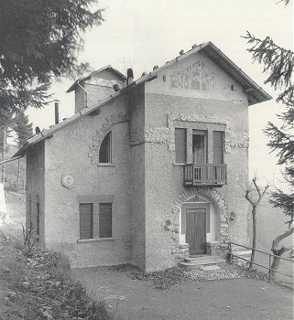

Sant’Elia,Villa Elisi, San Maurizio, Como, 1912

Source: <http://www.solarflarestudios.com/demosites/architecture/images/future1.jpg>

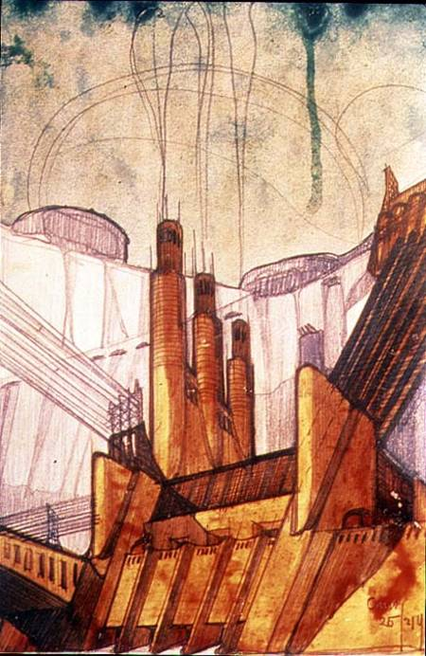

Sant’Elia, Electric Power Station, 1914

Source:[**http://www.art-prints-on-demand.com/kunst/antonio_santelia/electric_power_plant_1914_pen_hi.jpg**](http://www.art-prints-on-demand.com/kunst/antonio_santelia/electric_power_plant_1914_pen_hi.jpg)

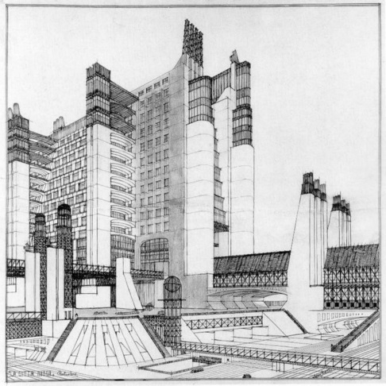

Sant’Elia, The New City, Tenement Building with Exterior Elevators, Gallery, Sheltered Passage over Three Levels, 1914, reproduced in the manifesto *Futurist Architecture.*

Source: <http://www.wired.com/images_blogs/photos/uncategorized/2008/11/11/santelia.jpg>

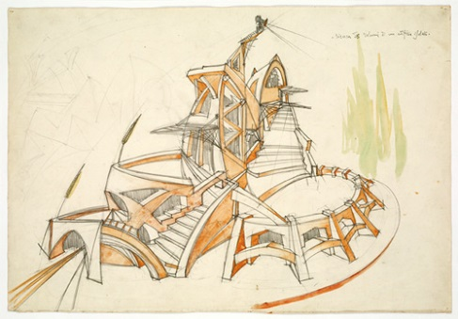

Virgilio Marchi, Architectural Study: Search for Volumes in a Building, 1919.

Source: <http://www.metmuseum.org/toah/images/h2/h2_1984.91.jpg>

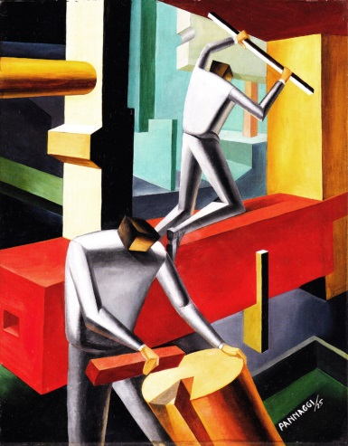

Ivo Pannaggi, I costruttori, 1925

Source: <http://www.atlantedellarteitaliana.it/immagine/00026/17716OP2882AU29785.jpg>

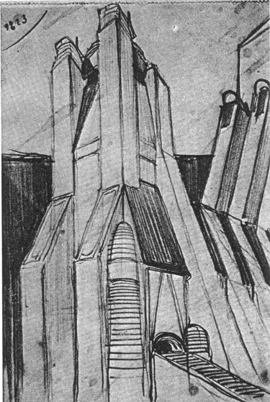

Sant’Elia, Monumental Building, 1910-1912

Source : <http://web.tiscali.it/antonio_santelia/images/galleria/036a.jpg>

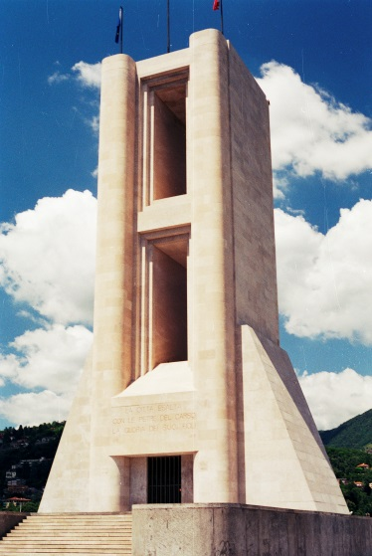

Giuseppe and Attilio Terragni, Monument to the Fallen, Como, 1931- 1933

Source : <http://farm5.staticflickr.com/4152/5065206736_316f48c285_o.jpg>

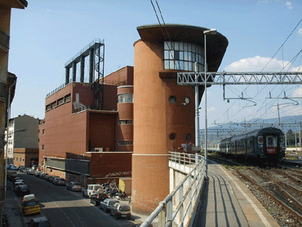

Angiolo Mazzoni, Heating Plant and Main Controls Cabin, Florence, 1933- 1935

Source: <http://www.limen.org/BBCC/tutela/Conservazione%20delle%20citt%E0/Toscana/Firenze/TAV/MAZZONI-2-370.gif>

**FUTURISM AND DANCE**

**Juliet Bellow, American University**

**Summary**

Dance, as both motif and medium, corresponds with several aspirations articulated in Futurist *manifesti*. An art form that employs movement as one of its key materials, dance lends itself to the Futurist goal of conveying speed and dynamism. By extension, dance operates in different temporal and spatial registers than painting, sculpture and poetry, media employed in the initial development of a Futurist aesthetic. Dances unfold sequentially, mingling memories of past actions with present perceptions; they occur in real space, as bodies interpenetrate with one another and their surroundings. Associated with modern, urban spaces of entertainment, dance also offered the Futurists a means to explore themes of technology, nightlife, and the crowd. Finally, dance served at the turn of the twentieth century as a primary vehicle for the invention of multimedia art forms—exemplified by the work of Loïe Fuller and the Ballets Russes—thus both mirroring and fueling Futurist experimentation with new genres such as the *serata* and *parole in libertà*. At the same time, dance posed problems endemic to Futurist art and ideology. The medium’s corporeal basis and its longstanding link with female practitioners proved an uncomfortable fit with the ideal Futurist subject, envisioned as a phallic fusion of human and machine. In turn, dance awakened Futurist anxieties about the resistance of somatic and sensual experience, of nature and matter, to their model of militant masculinity.

**Relationship to Modernism**

Dance first entered Futurism as a subject in other media. Gino Severini, in nearly 100 pictures on the theme executed between 1909 and 1916, linked dance with sensory immediacy as a means to ‘put the spectator at the center of the picture’—a key tenet of Umberto Boccioni’s 1910 ‘Futurist Painting: Technical Manifesto’. Based in Paris, Severini witnessed dance forms ranging from the theatrical stagings of Fuller and Isadora Duncan to social dances such as the tango and *danse de l’ours* (bear dance). In *Dynamic Hieroglyphic of the Bal Tabarin* (1912; Museum of Modern Art, New York), which pictures a popular nightclub south of Montmartre, Severini draws on Neo-Impressionism and Cubism to straddle representational and abstract modes. Partial glimpses of recognizable objects (streamers, skirt ruffles, top hats) commingle with actual objects (sequins affixed to the canvas that refract ambient light) and non-referential elements—lines, shapes and colours intended to evoke movement, sound, and touch. The breakdown of boundaries within and between bodies in this large canvas parallels the imagined entry of the viewer into the scene as a participant. Later works, such as *Dancer=Propeller=Sea* (1915; Metropolitan Museum of Art), use dance to illustrate Severini’s developing theory of ‘plastic analogy’, whereby the process of perception initiates a chain of sensory associations and mental images. The diagonal orientation of this large-scale oil painting enhances the implied movement of its abstract forms, creating the appearance of matter in flux. These swirling shapes, which simultaneously eclipse the performer’s body and materialize its dynamic action, allow Severini to analogize dance both to ocean waves and to airplane propellers, reconciling nature (gendered female in Futurist ideology) with the machine. In *Articulated Dancer* (1915; Fondazione Magnani-Rocca, Parma) Severini employs literal rather than implied kinetics. He rigs a marionette-like female dancer to a non-objective canvas with a system of pulleys, inviting the viewer with a parenthetical clause in the title to ‘pull the string and blow on the moving parts’, and thereby to serve as a partner in the dance the painting performs.

While Severini used dance to develop a Futurist painterly idiom, Futurist artists based in Rome experimented with the production of choreographic works. In 1914, Giacomo Balla conceived a ‘typographical ballet’ entitled *Macchina Tipografica* (*Printing Press*) in which twelve actors impersonate the movements and sounds of a newspaper typesetting machine. Perhaps inspired by F.T. Marinetti’s poetic declamations and the genre of *parole in libertà*, Balla envisioned the dancers as alphabetic letters, devising an onomatopoeic text to be recited during the performance. Serge Diaghilev, based in Rome at that time, considered staging *Printing Press* as a Ballets Russes production. Instead, he opted to realize another of Balla’s theatrical concepts, the ‘dancerless ballet’ *Feu d’artifice* (*Fireworks*, 1917), set to a score by Igor Stravinsky. Staged only once, on 12 April 1917 at the Teatro Costanzi in Rome, *Feu d’artifice* consisted of a sculptural set of geometric constructions onto which colored electric lights were projected, glancing off the set at changing intervals. Dispensing with narrative, subject matter, and even the live performer, this spectacle of pure light, color, and sound partly fulfills the Futurist aim to extinguish the static object and produce dynamism itself. Sketches for this production resemble Balla’s abstract images of political demonstrations, such as *Flags on the Altar of the Country* (1915; Galleria Nazionale d’Arts Moderna, Rome). This connection suggests that dance, for Balla, bore the potential to unify individuals, to harness their energy, and to galvanize a crowd into action—aims directly linked to the Futurists’ nationalistic project during the First World War.

During the same years, the Paris-based dancer and poet Valentine de Saint-Point invented a hybrid, dance-based art form called *Métachorie*, which she affiliated with Futurism. Author of the ‘Manifesto of Futurist Women’ and the ‘Futurist Manifesto of Lust’, Saint-Point aimed to transcend the gendered division of body and spirit in Futurist rhetoric. Accordingly, she conceived of *Métachorie* as an ‘idéist dance’ that combined the sensual rhythm of music with the cerebral rhythm of poetry and the geometric stylization of the plastic arts. The first performance of *Metachoric Dances*, on 20 December 1913 at the Comédie des Champs-Élysées, consisted of a solo dance in four sections, labeled ‘Poems of Love’, ‘Atmospheric Poems’, ‘Pantheistic Poems’, and ‘Poems of War’, in which Saint-Point employed a style ranging from sharp and angular to soft, flowing movement. With geometric abstractions projected behind the dancer and a sonoric accompaniment that combined poems by Saint-Point (declaimed by the actor Édouard de Max) and music adapted from compositions by Florent Schmitt, Claude Debussy, Erik Satie, and Francesco Pratella, and perfume wafting through the hall, the *Metachoric Dances* attempted to engage viewers in both mind and body. However, Marinetti repudiated *Métachorie* in his 1917 ‘Manifesto of Futurist Dance’, published after Saint-Point’s second presentation of the genre at the Metropolitan Opera House in New York on 3 April 1917. Critiquing *Métachorie* as ‘static’, ‘emotionless’, and ‘passéiste’, Marinetti called for a more heroic form premised upon the dancer’s fusion with ‘the divine machines of speed and war’—a prescription fulfilled by Giannina Censi’s ‘Aerodanze’, performed on 31 October 1931 at the Galleria Pesaro in Milan, accompanied by poetic declamation by Marinetti and a backdrop of paintings by Enrico Prampolini. Dressed in a shimmering bodystocking and aviator’s helmet, Censi performed movements evoking simultaneously the mechanics of an airplane and the bodily experience of flight. Like the genre of *aeropittura* (aerial painting), invented in 1929, Censi’s ‘Aerodanze’ tie the Futurist worship of the machine to the Fascist image of Benito Mussolini as the nation’s pilot.

**References and further reading**

Berghaus, G. (1993) “Dance and the Futurist Woman: The Work of Valentine de Saint-Point (1875-1953).” *Dance Research: The Journal of the Society for Dance Research* 11, no. 2, 27-42.

Fonti, D. (2001) *Gino Severini: The Dance 1906-1916*. Milan: Skira.

Klöck, A. (1999) “Of Cyborg Technologies and Fascistized Mermaids: Giannina Censi’s ‘Aerodanze’ in 1930s Italy.” *Theatre Journal* 51, no. 4, 395-415.

Locke, N. “Valentine de Saint-Point and the Fascist Construction of Woman,” in Affron and Antliff, eds., *Fascist Visions*: pages.

Poggi, C. (2008) *Inventing Futurism: The Art and Politics of Artificial Optimism*. Princeton: Princeton University Press.

Veroli, P. “The Futurist Aesthetic and Dance,” in Berghaus, ed.

**Images**

Giannina Censi in aerofuturista, 1931

<http://proa.org/esp/exhibition-el-universo-futurista-obras-sala-4-6.php>

Severini's Dancer=Propeller=Sea, 1915

<http://www.metmuseum.org/collection/the-collection-online/search/488472>

**FUTURIST MUSIC**

**Adrian Curtin, University of Exeter**

Francesco Balilla Pratella (1880-1955) was the first composer to associate with the Futurist movement and to outline an aesthetic of Futurist music, though he was ultimately superseded in this regard by the painter-turned-musician Luigi Russolo (1885-1947), who became most closely associated with this stylistic. In his three manifestos on the subject, written between 1910 and 1912, Pratella echoes F.T. Marinetti’s call to revolutionize art and reject the stultifying effects of *passéism*. He does not provide a coherent or convincing programme for how this might be achieved in music, however, and his efforts to realise Futurist music in practise – one of which, *Inno alla Vita* (*Hymn to Life*, 1913) involved whole-tone scales – were not especially radical. Russolo proposed an altogether more fundamental rethinking of what Futurist music might be. In his 1913 manifesto L'arte dei rumori (*The Art of Noises*), Russolo argues that the sounds offered by a symphony orchestra are a poor match for the acoustic force and timbral complexities of a modern city. He proposes to transform noise using newly invented instruments, aestheticizing and spiritualizing it in the process. He devised a system of enharmonic notation, and, with the help of the painter Ugo Piatti, constructed the *intonarumori* (noise intoners) that were to constitute the new Futurist orchestra. Russolo’s noise instruments consisted of rectangular, plywood boxes containing motorized mechanics that made unique sounds that an operator (musician) could manipulate in terms of pitch by pulling on a lever. The orchestra of *intonarumori* included such instruments as the exploder, crackler, buzzer, stamper, gurgler, screamer, rustler, whistler, thunderer, and the croaker. Pieces Russolo composed for the *intonarumori* include *Risveglio di una città* (*Awakening of a City*) (1913) and *Convegno di automobili e di aeroplani* (*A Meeting of Motorcars and Aeroplanes*) (1913). Noise music was played sporadically at Futurist performance events and concerts in Europe over the next decade or so and achieved notoriety, though performances were often met with incomprehension and derision.

In the Russian avant-garde, a notable example of what might be termed Futurist music was a mass concert designed by Arseny Avraamov entitled *The Symphony of Sirens*, which took place in Baku in 1922. Avraamov’s symphony was a grandiose expression of proletarian music-making, i.e. music made by and for workers, and featured ‘instruments’ of modern technology and industry that workers could perform themselves, such as factory whistles, guns, and modes of transportation.

In making music out of worldly sound (including that which may be deemed to be noise), Futurist music contributed to the modernist expansion of aesthetic possibilities; it serves as an important precedent for the work of later composers, John Cage in particular.

**REFERENCES AND FURTHER READING**

AVRAAMOV, A. 1992. The Symphony of Sirens (1923). *In:* KAHN, D. & WHITEHEAD, G. (eds.) *Wireless Imagination: Sound, Radio, and the Avant-Garde.* Cambridge, Mass.; London: MIT Press.

BROWN, B. 1981-1982. The Noise Instruments of Luigi Russolo. *Perspectives of New Music,* 20**,** 31-48.

CHESSA, L. 2012. *Luigi Russolo, Futurist: Noise, Visual Arts, and the Occult,* Berkeley, University of California Press.

KAHN, D. 1999. *Noise, Water, Meat: A History of Sound in the Arts,* Cambridge, Mass., MIT Press.

PRATELLA, F.B. 1910. *Manifesto del musicisti futuristi*, Milan.

PRATELLA, F.B. 1911. *Manifesto tecnico della musica futurista*, Milan.

PRATELLA, F.B. 1912. *La distruzione della quadratura*, Bologna.